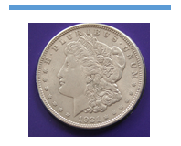



**\*ESTATE COIN AUCTION\***

SATURDAY, MARCH 29th, 2014 @ 11:00 A.M.

DOORS OPEN AT 9:00 A.M.

AMERICAN LEGION HALL (UPTOWN ANKENY)

521 S.W. 3RD STREET

ANKENY, IOWA 50021

**EXCEPTIONAL COIN COLLECTION! $10/$20/$25 GOLD COINS!!**



**\*\*FEATURING\*\***

**2009 $20 ULTRA HIGH RELIEF DOUBLE EAGLE 24CT GOLD COIN MS 70 1908 $10 MOTTO GOLD COIN MS 62**

**(20)- 2008 AMERICAN EAGLE $25 GOLD PIECES MS 69 1914-D $10 GOLD COIN MS 62**

**(2)- 1910-D $10 GOLD COIN MS 62 1914 $10 GOLD COIN MS 62**

FULL CATALOG AVAILABLE-317 LOTS VIEW AT AUCTIONZIP.COM-ID#34830

**ONLINE BIDDING** AVAILABLE AT AUCTIONZIP.COM-ID #34830

100+ Silver Dollars (Morgan, American Eagle, Peace)

100’s of Presidential Coins Uncirculated

Obsolete Racketeer Nickels

Eisenhower Coins

Sacagawea Golden Dollars Uncirculated

24KT Gold Slabs

2009 Buffalo Silver Coins

American Half Dollars Collections

2007 Layered Dollars

1979-1999 Susan B. Anthony Uncirculated

Lincoln/Obama Painted Coins

JFK Half Dollar Collections

San Francisco Coin Collections

Abraham Lincoln Gettysburg Address Coin

1880-1890 Morgan Silver Dollars Uncirculated

1936 Buffalo Nickel Set

Quarter Proof Sets

National Parks Quarters

1921-1926 Peace Dollars

2 Tone Gold Plated Eagle w/COA

Rolls of Uncirculated State Quarters

1894 Double Eagle Proofs (Non-Monetary)

2001 American Eagle Copper Coins

1963 D Franklin Silver Half Dollars

1944 Liberty Walking Silver Half Dollars

Rolls of Presidential Dollars Uncirculated   
Unbroken Vault Rolls of Presidential Coins

1905-1907 Indian Head Pennies

1913 Liberty Dimes in cases

Roman Bronze Coin

2008 Hillary Clinton Gold Coin

2008 Bald Eagle Copper Nickel

Display Cases

Stamp/Coin Collections

Presidential Gallery Collection

Plus much more!

Auctioneers note: ***This will be an excellent auction full of Quality Coins…You won’t want to miss this one!***

Terms of Sales: All bidders must register with proper ID to obtain a bid number. All Items must be settled for day of auction, prior to removal from the property, with Cash, Good Check or Credit Card (3% Charge for Credit Card Usage). **All items purchased will be released to the buyer after payment has been made the day of auction (After payment to clerk).** Announcements day of sale take precedence over printed advertising. Not responsible for accidents, theft, or inadvertent errors in advertising. All items are being sold “As-Is” and represented to the best of our knowledge.



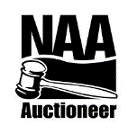<FOOD BY COUNTRY CATERING>

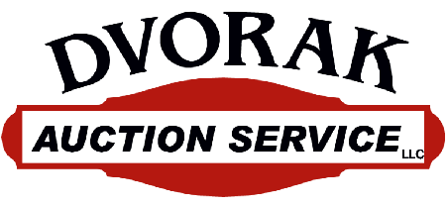

VIEW AUCTION AT: DVORAKAUCTIONSERVICE.COM

AUCTIONZIP.COM-AUCTIONEER ID#34830

PHONE: 515-238-9685

EMAIL: DVORAK71@GMAIL.COM

AUCTIONEER: JASON DVORAK

MADRID, IOWA